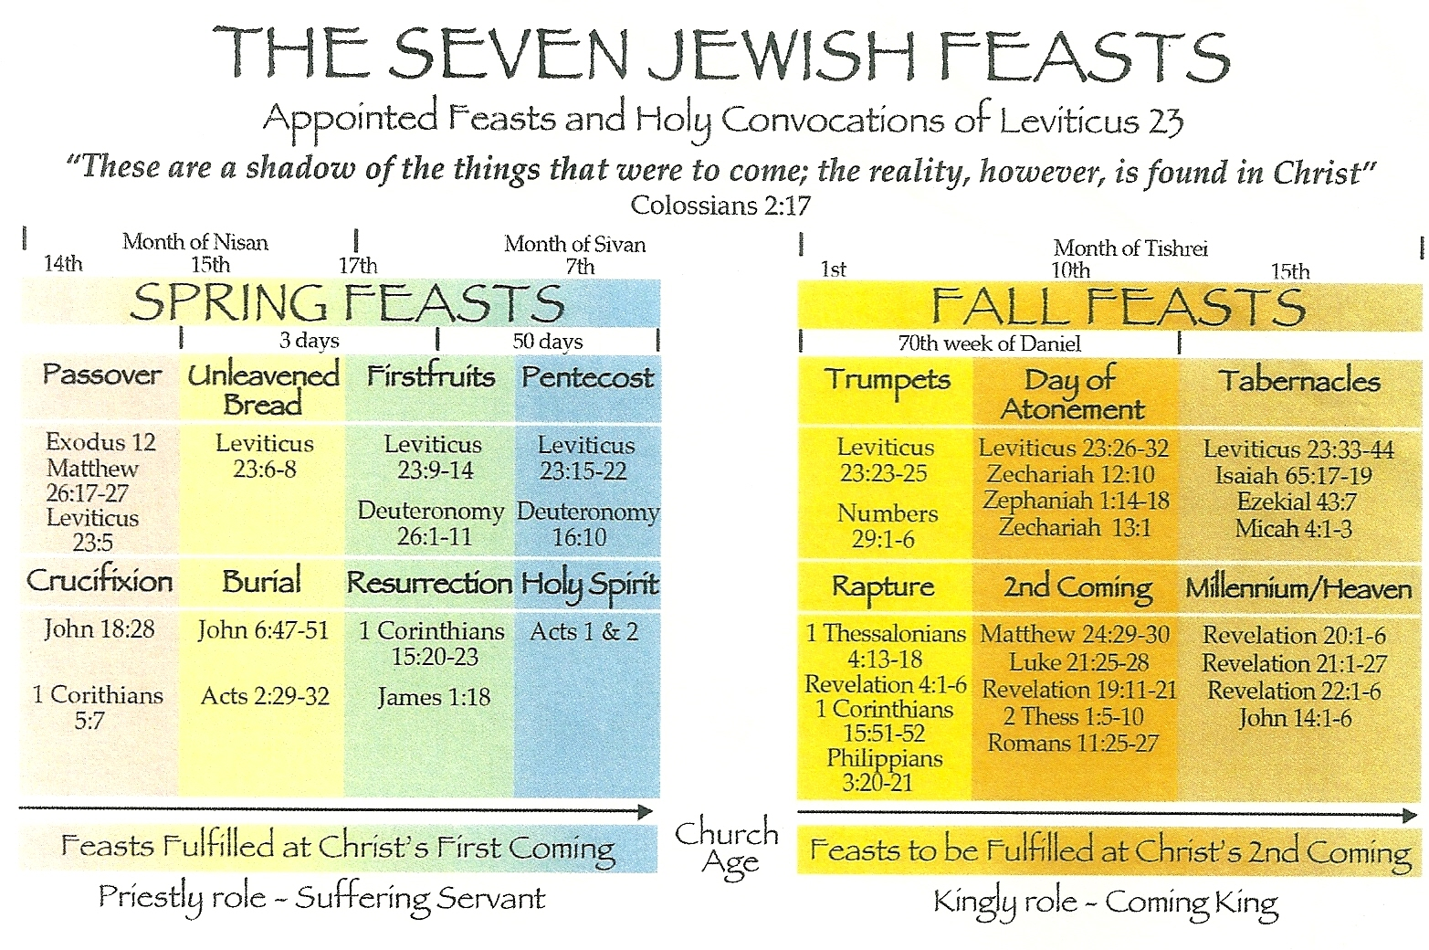

The Family Name – Eph 3:14-15
1. There is One Family through One ____________

2. We must have the ___________________ of the Name and not just use it.
- Acts 19:13-15

- Matt 7:21-23
3. Where we get the __________ Name?
- Gen 17:9-14

- Luke 1:59-63
4. New Testament Circumcision
- Col 2:11-12

- James 2:7

- Acts 15:17

- Gal 3:27

5. Becoming Born ______________
- John 3:3-5

- Acts 8:16, 19:5

- I Cor 1:13
W.E Vine – The Baptized person was closely bound to- or became the property of the one into whose name he was baptized

